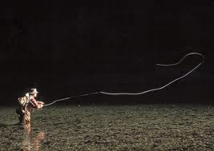
Backyard Adventures

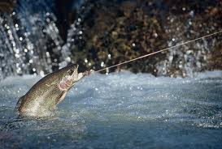
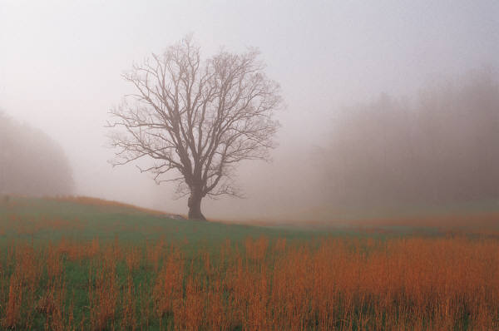
July Special

This month we have partnered with Wet Feather Fly-fishing and Hill Top Hotels to provide guests with a 4-day/ 3-night stay at the Hill Top Hotels in Kamas Utah and 3 full day guided trip on the Weber River, Upper Provo River, and Middle Provo River. Prices start at $1100 and can be adjusted for your needs such as: equipment, airport pickup, dinning, etc.

July 1-30, 2014
Hill Top Hotels
555 N River view Ave
Kamas, UT 84000

For reservations and price quotes please contact:
Austin Blain
Backyard Adventures
(800) 555-1234

